**King Abdul Aziz University**

**Faculty of Computing and Information Technology**

**Department of Computer Science**

**Senior Project CPCS-498**

Developing an Online Developers Community (Final Report)

28.02.2018

## Prepared by

Azargul Nazari (1414322)

Supervisors

Prof. Isa Fathi & Prof. Kamal Jambi

**Table of Contents**

**Abstract**2

**Introduction**3

Motivation 3

**Project Proposal**3

Problem Definition 3

Project Scope 4

Project Type 4

Target Users 4

Suggested Solution 4

**Project Management**4

Work Breakdown Structure (WBC) 4

**Project Technologies**6

Languages 6

**Future Work**7

**References:**14

# Abstract

The aim of this project is to develop an online community to let the programmers chat and share their ideas or to generate their UML diagram from their PHP source code.

# Introduction

Though, there are many online communities which their main aim is to keep connected the developers around the world, these communities have different ways of communication such as GitHub which let the developers to communicate through sharing codes and commenting on a specific issue of the code, Stack Overflow is another Q&A website for developers which lets the developers to answer, share and develop each others problem and there are many other websites such as StackExchange, Quora, Medium, Mozilla Developer Network and many others. What I really didn’t observe during my research about online developers communities is that there isn’t such a website which allow the software developers to communicate through exchangning their UML diagrams through generating from source code. For example, a developer wants to generated the UML diagram of its source code, so let's take an example, you have coded a new software and there are some other developers who want to see your code in UML diagram format, in this case you can communicate with other developers through a media which could generate UML diagram from your PHP source code. My project is about to creating a UML generator system as well as a chat application to let developers to chat and exchange their generated UML diagram.

This project is a web based application (client-server) which let the public users to visit different available communities (chatrooms) and see and chat with other developers, if the user wants to share his/her idea then he/she needs to be signed in or sign up to the system. To generate UML diagram, users should upload their module of PHP code to the server and server has the responsiblity to generate UML image of their source code.

## Motivation

One of the main reason behind why I want to develop this project is because of the extreme interest which I have toward web technologies and software development related works which led me to learn more about new web technologies during development of this project and since, I started, I am very passionate about my project.

# Project Proposal

## Problem Definition

This project is about to create an online community for developers which will be a web application and this application will have many features to be implemented. For example, this website will have the following features: generating UML diagram from PHP source code, chat servervice for different communities, ranking different communites, creating new communities, and adding communities to the favorite list.

One of the main focus is to solve the the problem of auto generating UML diagram from PHP source code. There isn’t such an online tool to convert PHP source code into UML diagram just by uploading the source code. This project is about to create a web application to generate UML diagram for the programmers as well as this application will provide many other service as it’s mentioned on the above.

### **Project Scope**

The scope of the project is:

* Creating a web application to generate UML diagram from PHP source code
* Creating a client side interface to show the generated UML diagram
* Creating the chat service for the users
* Learning full stack development

### 

### **Project Type**

The type of this project is a web application.

### **Target Users**

The main users of this project will be the **developers**.

## Suggested Solution

This project is a web application and every features of this application is pretty clearn through the UML diagrams you can see the solution and for the auto UML genrator here is the solution.

In the server side, I will create a program that will read the uploaded source code files from the clients and extracts the class information (properties, methods, relationships) of each individual source files and store them on a specific object. I will use the help of phuml library and plug it to the server side where it can generate the image of UML diagram. The server will sends back the image of the source code’s UML to the client. The client side will show the UML’s image in an appropriate format.

# Project Management

## Work Breakdown Structure (WBC)

Work Breakdown Structure is one of the best ways to break a large or difficult task into more smaller, more manageable subtasks. So, Work Breakdown Structure helps team members to know what tasks that must be done to complete the project and to understand how all of the tasks fit into the overall design project. In summary, Work Breakdown Structure defines and groups a project's discrete work elements in a way that helps organize and define the total work scope of the project[1]. WBC shown in figure 1.

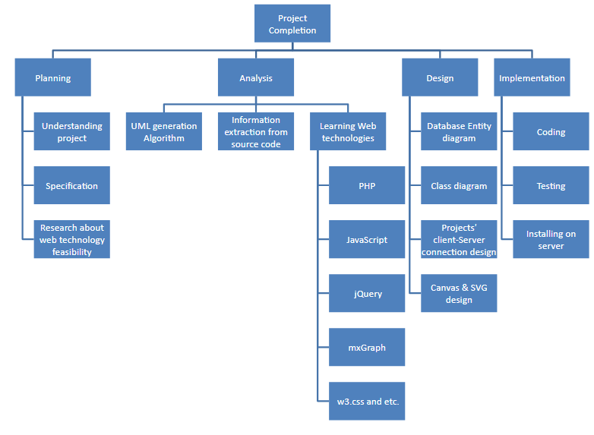

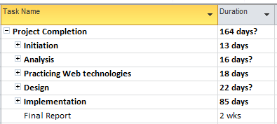

Figure 2. Shows the time estimation for complete project

Gantt Chart

In the below figure, you will see the project’s total tasks in Gantt chart format which during these two semesters it will be done.

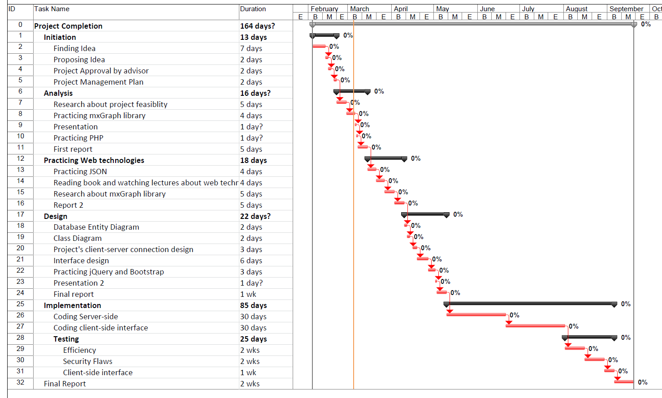

Figure 3. Gantt Chart of the entire project

# Project Technologies

## Languages

* **PHP**: PHP originally stood for Personal Home Page, but it now stands for the recursive acronym PHP: Hypertext Preprocessor. PHP code may be embedded into HTML code, or it can be used in combination with various web template systems, web content management systems, and web frameworks[1].
* **JavaScript** : JavaScript is a cross-platform, object-oriented scripting language. It is a small and lightweight language. Client-side JavaScript extends the core language by supplying objects to control a browser and its Document Object Model (DOM)[2].
* **MySQL** : MySQL is a freely available open source Relational Database Management System (RDBMS) that uses Structured Query Language (SQL). SQL is the most popular language for adding, accessing and managing content in a database. It is most noted for its quick processing, proven reliability, ease and flexibility of use[3].
* **HTML** : HTML (Hypertext Markup Language) is the set of markup symbols or codes inserted in a file intended for display on a World Wide Web browser page. The markup tells the Web browser how to display a Web page's words and images for the user[4].
* **CSS**: CSS stands for Cascading Style Sheets. CSS describes how HTML elements are to be displayed on screen, paper, or in other media. CSS saves a lot of work. It can control the layout of multiple web pages all at once[5].

FrameWorks:

* **jQuery** : jQuery is a fast, small, and feature-rich JavaScript library. It makes things like HTML document traversal and manipulation, event handling, animation, and Ajax much simpler with an easy-to-use API that works across a multitude of browsers[6].
* **W3.CSS**: W3.CSS is a modern CSS framework with built-in responsiveness: Smaller and faster than any other CSS frameworks[7].
* **Phuml**: a php library for generating image of UML
* **Other jQuery Plugins**

# Detailed Requirements Specification

Functional Requirements:

* **Search Community**: users can search for a specific community
* **View Community Chat**: users can read the chats of a specific community
* **Create New Community**: users can create a new community
* **Sign In**: users can sign in to open his/her account
* **Sign Up**: users can register an account into the system
* **Chat**: users can send message into community chat room
* **Rate**: users can rate the specific language or framework through 5 stars rating
* **Generate UML**: user can upload source code and generate it’s UML diagram

Non-Functional Requirements:

* **Security**
* **Maintainability**
* **Response Time**
* **Good User Interface**

# Analysis & design

Initial Design Prototype

**Main Page**

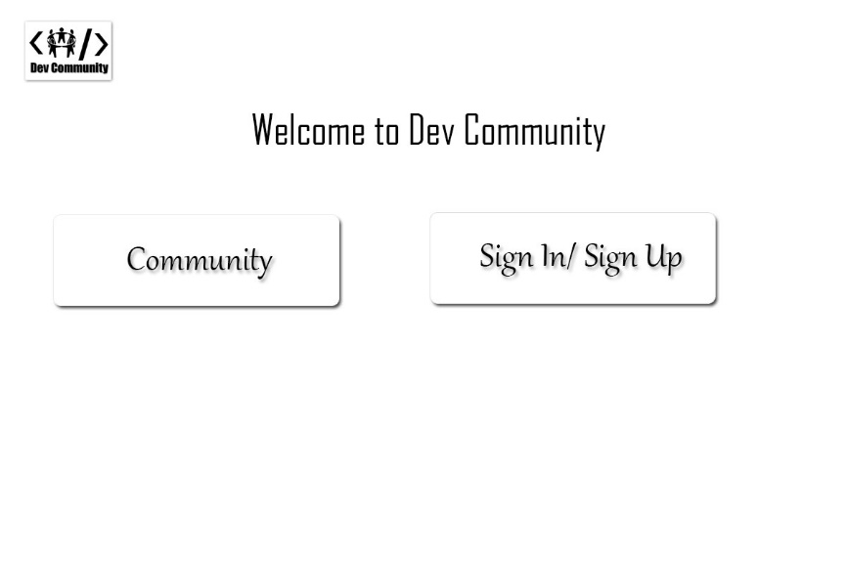

**Search Community**

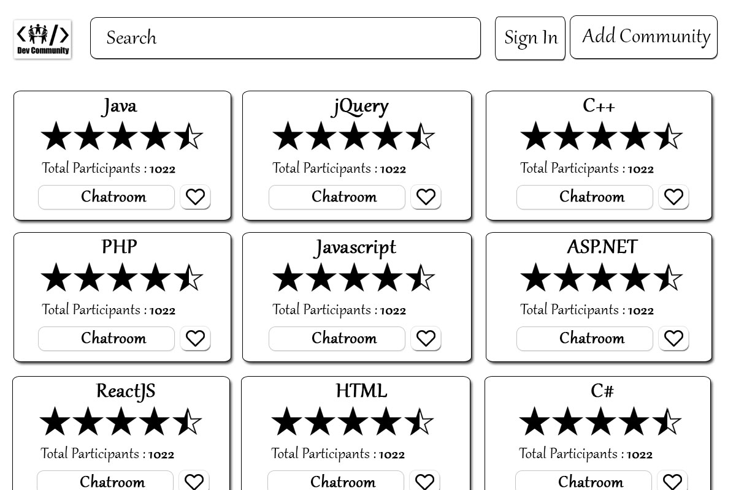

**Chat Room**

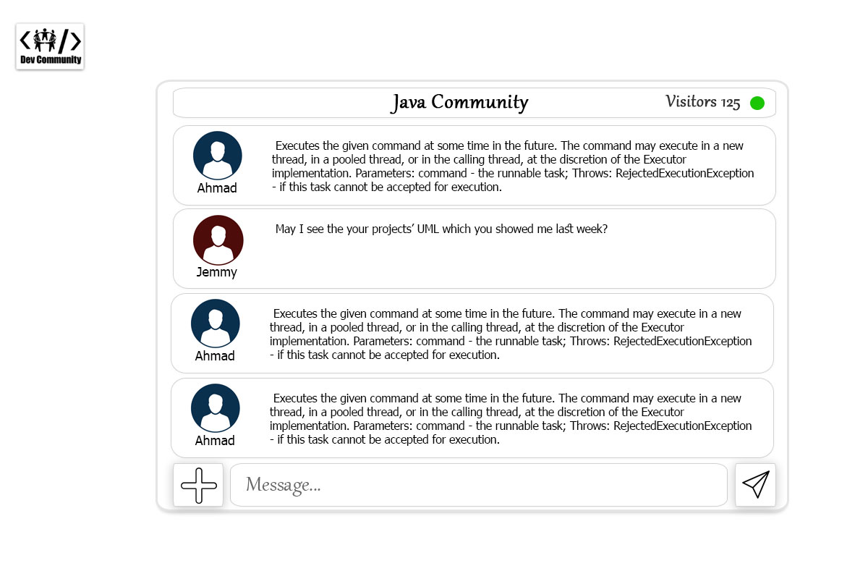

**Uploading File For UML Generation**

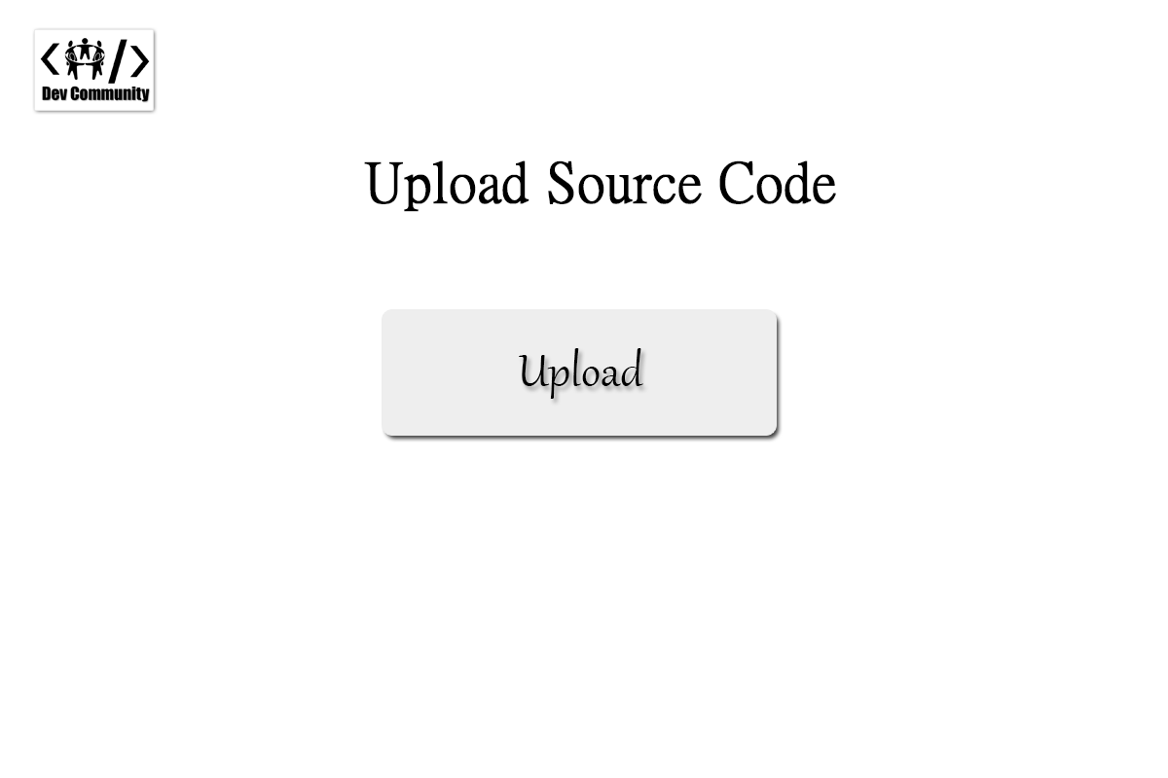

**UML Generation**

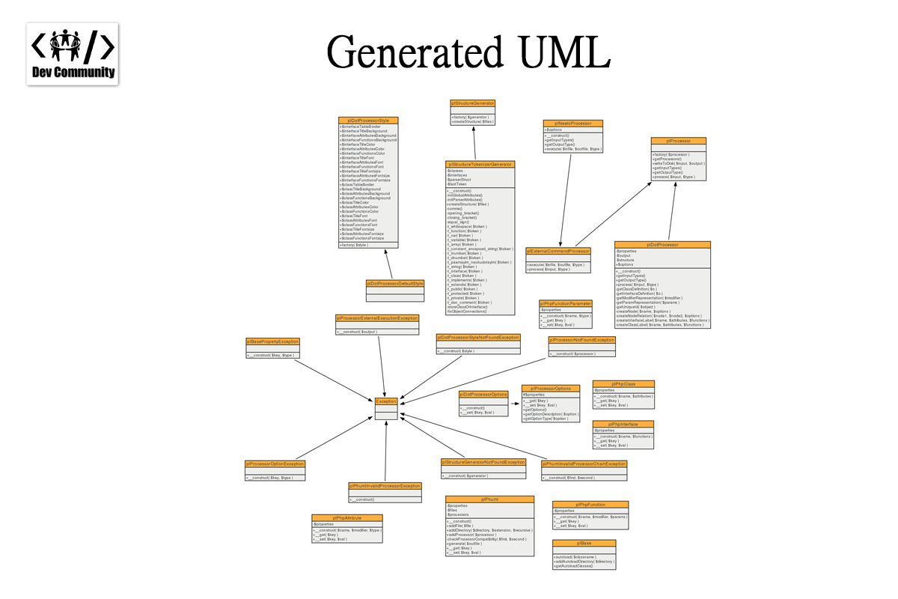

**Page for registration of a new community**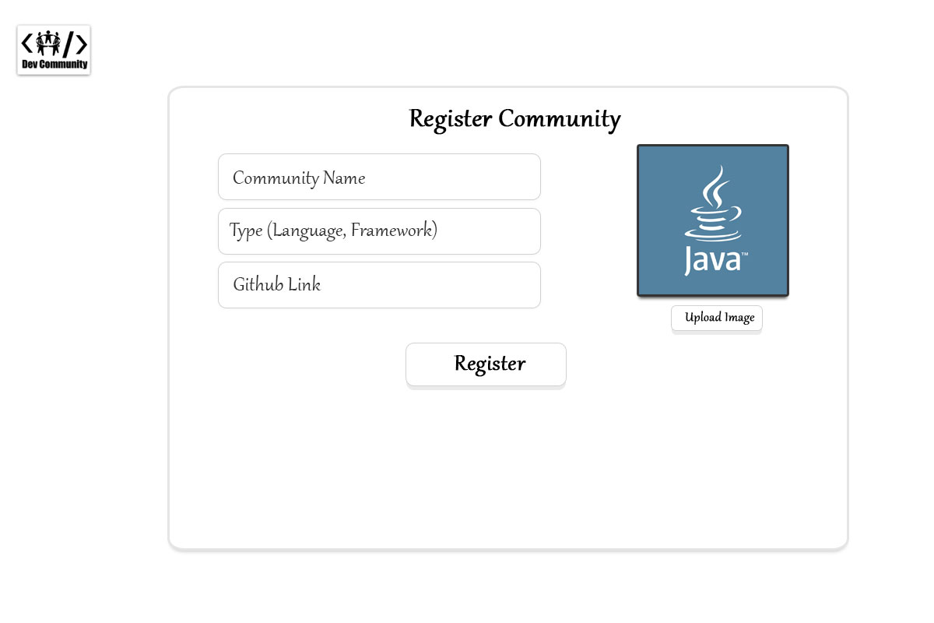

**Sign In page**

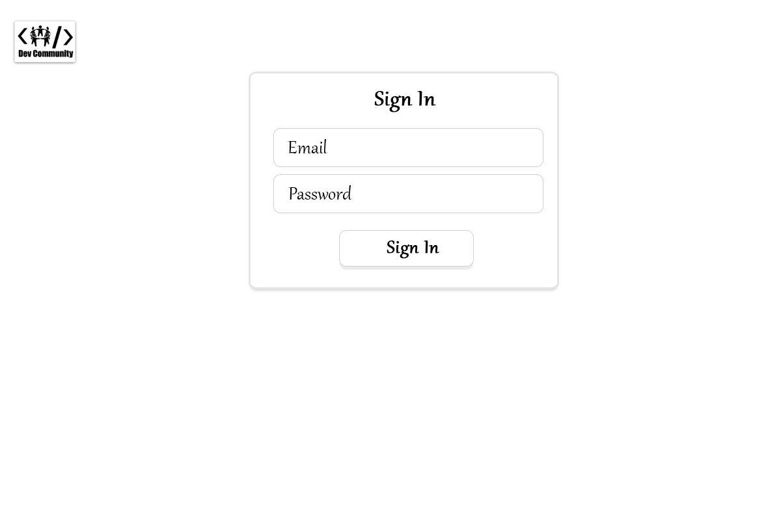

**Sign Up Page**

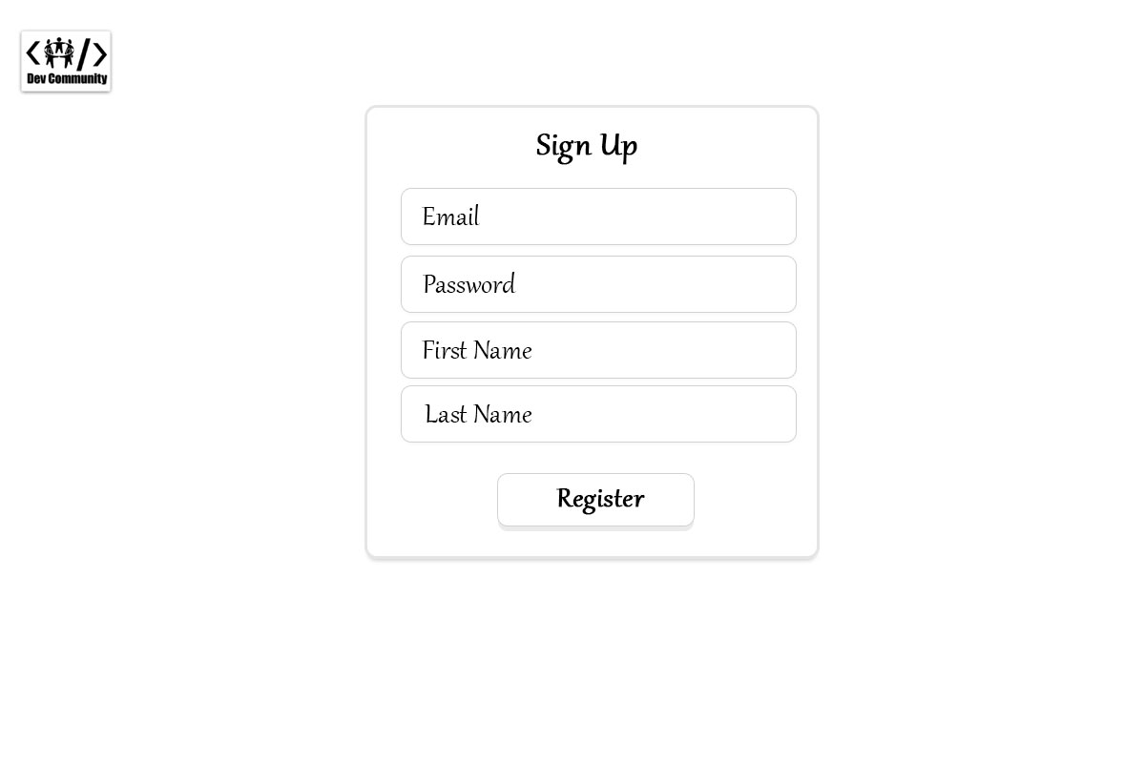

Flow Chart

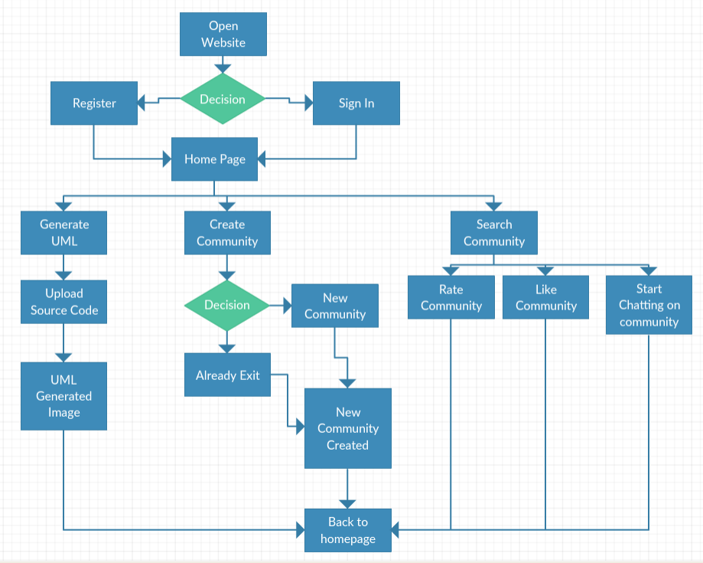

Use Case Diagram

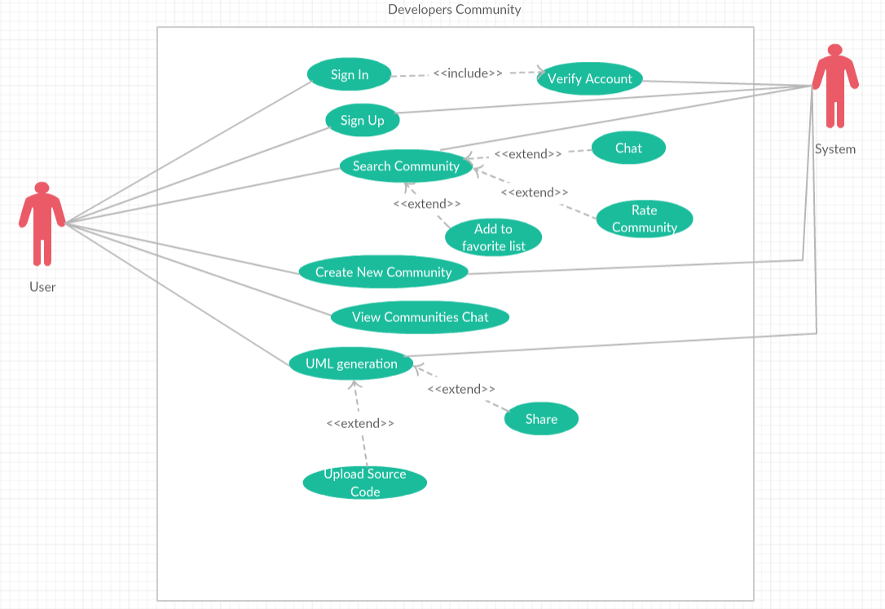

Class Diagram

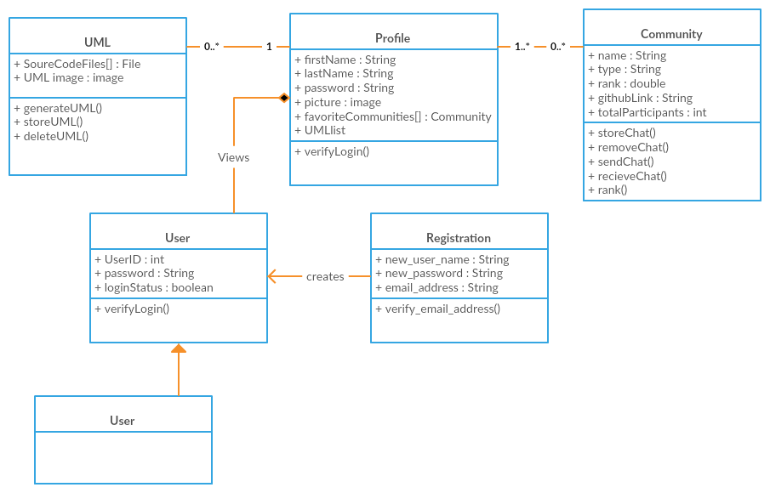

ER (Entity Relationship) diagram

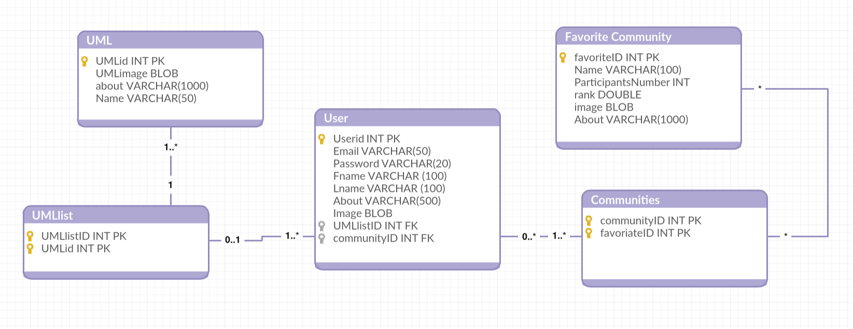

# Future Work

According to the plan, I will start working on the implementation phase.

# Conclusion

This project is a web application which let the developers to communicate with each other or to generate UML diagram, the main features of this website will be:

* Auto UML generator from PHP source code
* Chat sevvice fo rthe users
* Rating commuities server for the users
* Adding communites as favorite community

# References:

1. <https://en.wikipedia.org/wiki/PHP>
2. <https://developer.mozilla.org/en-US/docs/Web/JavaScript/Guide/Introduction>
3. <https://www.siteground.com/tutorials/php-mysql/mysql/>
4. <https://searchmicroservices.techtarget.com/definition/HTML-Hypertext-Markup-Language>
5. <https://jquery.com>
6. <https://www.w3schools.com/w3css>